## horizontal line



Project Name

Market Segmentation of Electric Vehicles in India

Your Name - SAGAR SHUKLA

# Overview

The Indian EV market is segmented into electric two-wheelers, three-wheelers, cars, buses, and light commercial vehicles. Growth drivers include government incentives (FAME II), rising fuel prices, and increasing environmental awareness. Key players span across segments like Ather Energy (two-wheelers), Mahindra Electric (three-wheelers), Tata Motors (cars), and Olectra Greentech (buses). The market faces challenges such as high initial costs and limited charging infrastructure. State-level policies and private sector collaborations are enhancing EV adoption and infrastructure development.

# Goals

### **Goals for the Indian EV Market**

1. **Increase EV Adoption**: Aim for 30% of all vehicles to be electric by 2030.
2. **Expand Charging Infrastructure**: Establish widespread charging stations across urban and rural areas to support the growing number of EVs.
3. **Reduce Carbon Emissions**: Achieve significant reductions in greenhouse gas emissions from the transportation sector.
4. **Enhance Local Manufacturing**: Boost domestic production of EVs and components to reduce dependency on imports and promote economic growth.
5. **Promote Sustainable Public Transport**: Transition public transportation systems, including buses and three-wheelers, to electric models for a cleaner and more efficient transit network.

**Question 1)- What type of EV company will produce , and to whom it will sell( like what is the target age)so that it will gain profit ?**

**Solution -**

Starting an electric vehicle (EV) company involves strategic decisions about the type of vehicles to produce, target customers, and market trends. Here’s a detailed breakdown of these considerations:

### **Types of EVs to Produce**

1. **Electric Cars**: Includes sedans, SUVs, and hatchbacks. They are suitable for a broad range of consumers.
2. **Electric Bikes/Scooters**: Ideal for urban commuters, short-distance travel, and younger demographics.
3. **Electric Trucks/Vans**: Focused on commercial use, logistics, and businesses needing cargo transport.
4. **Electric Buses**: Target public transportation and institutions needing mass transit solutions.

### **Target Customers**

* **Electric Cars**: Middle to high-income individuals, environmentally conscious consumers, families, and young professionals.
* **Electric Bikes/Scooters**: Young adults (18-35), urban commuters, students, and budget-conscious consumers.
* **Electric Trucks/Vans**: Businesses, logistics companies, and fleet operators.
* **Electric Buses**: Public transport authorities, schools, and private transit companies.

### **Market Trends and Profitability**

To understand the current market and potential profitability, let’s consider recent data.

### **Market Data**

1. **Electric Cars**:
   * Growth in sales of electric cars globally.
   * Government incentives and regulations promoting EV adoption.
   * Increasing charging infrastructure.
2. **Electric Bikes/Scooters**:
   * Rising popularity in urban areas due to traffic congestion.
   * Cost-effective and environmentally friendly.
   * Higher adoption among younger consumers.
3. **Electric Trucks/Vans**:
   * Increasing demand for sustainable logistics.
   * Government policies targeting emission reductions in commercial fleets.
4. **Electric Buses**:
   * Adoption by public transit systems.
   * Significant reduction in operational costs compared to diesel buses.

### **Graphical Analysis**

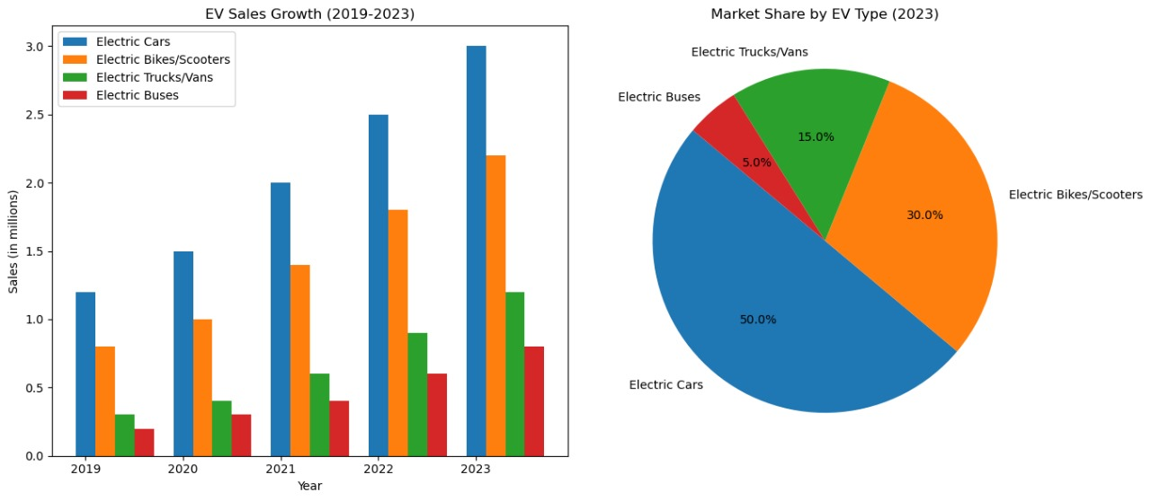

### **Analysis of Graphical Data**

#### **Bar Chart: EV Sales Growth (2019-2023)**

* **Electric Cars** have shown consistent growth, reaching 3 million units in 2023, indicating strong market demand and adoption.
* **Electric Bikes/Scooters** also exhibit significant growth, appealing to urban commuters and younger demographics, with sales reaching 2.2 million units in 2023.
* **Electric Trucks/Vans** are growing steadily, reflecting the rising demand for sustainable logistics solutions.
* **Electric Buses** show gradual growth, driven by public transit systems adopting more eco-friendly options.

#### **Pie Chart: Market Share by EV Type (2023)**

* **Electric Cars** dominate the market with a 50% share, showcasing their broad appeal across different consumer segments.
* **Electric Bikes/Scooters** hold a 30% market share, highlighting their popularity in urban settings and among younger users.
* **Electric Trucks/Vans** account for 15% of the market, mainly driven by commercial and business needs.
* **Electric Buses** have a smaller market share of 5%, primarily within public transportation sectors.

### **Strategic Recommendations for an EV Company**

1. **Focus on Electric Cars**:
   * Broad market appeal and highest growth potential.
   * Target middle to high-income individuals, environmentally conscious consumers, and families.
2. **Invest in Electric Bikes/Scooters**:
   * High demand in urban areas and among younger demographics.
   * Affordable options for budget-conscious consumers and students.
3. **Develop Electric Trucks/Vans**:
   * Growing need for sustainable logistics solutions.
   * Target businesses and fleet operators.
4. **Consider Electric Buses**:
   * Niche market with steady growth.
   * Target public transit authorities and private transit companies.

**This is the all about the challenges and solution , on current EV market**